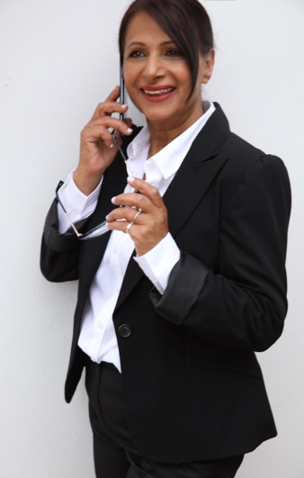
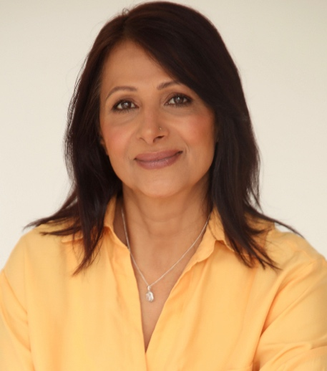
Curriculum Vitae: Daljit Booparai

dalbooparai1363@gmail.com
Date of Birth: 13/08/1963
National Insurance No. NA647933C
UK Model, Actor, Supporting Artist, Body Double

PHYSICAL ATTRIBUTES
Location: Derbyshire, East & West Midlands
General: South Asian Appearance, able to play Indian, Pakistani, Middle Eastern, South/ Central American
European Height: 5’3
Hair: Shoulder length brown/chestnut
Eyes: Brown
Playing Age: 45 – 60
Build: Slim, Dress Size 10/12
Accents/Dialects: English RP, German, Punjabi. UK regional: Birmingham
Full, Clean Driving Licence.

FILM / TELEVISION

2023 February Sexy Beast, SA Classy High Street Shopper
Ruby Speaking, SA Window Salesperson
Modelling, Headshots
BBC Boiling Point, SA Restaurant and Bar Customer, Multiple dates

2023 January The Boat, SA High Class Restaurant Customer
BBC Doctors, SA Receptionist
Photoshoot with James Corbett
Ruby Speaking, SA Western Windows Salesperson

2022 August Upgraded, Amazon Prime, SA Art Auction Buyer
Pooja Productions Bollywood, Capsule Gill, Villager, SA
Hollyoaks, SA
BBC Champion, SA
BBC Doctors, SA
ITV Maternal, Party Guest SA
Binny & Baba Party Guest SA
Modelling Photo Shoot, Amii Herd Photography

2022 July Pooja Productions Bollywood, Capsule Gill, Villager, SA
CBBC Phoenix Rise, Parent SA
Beauty & Brains Pageant, London
Model Camp, Models Meeting
CBBC Phoenix Rise, Dinner Lady, SA
Ted Lasso, Audience Member, SA
BBC Doctors, SA

2022 June Malpractice, Party Guest, SA
ITV Midsomer Murders, Senior Criminal Officer, SA
CBBC Phoenix Rise, SA
Better, Sisters SA
In Camera, Acting Role -Sewing Machinist

2022 May Music Video for Feature Film. Actor – Villager Attacking Police Officer for film Komuram
Bheemudo (Telegu)
ITV Midsomer Murders, Senior Criminal Officer, SA
ISS Global, Corporate Advert, featured SA
ITV Midsomer Murders, Senior Criminal Officer, SA
BBC Doctors, Consultant SA
ITV Full Monty, Manchester Passerby SA

2022 April ITV Midsomer Murders, Senior Criminal Officer, SA
Loveless, Commuter SA
ITV Midsomer Murders, Senior Criminal Officer, SA
Hard to Reach, Train Passenger Loughborough, SA
Corporate, Shell Advert, Neighbourhood Community

2022 March ITV Midsomer Murders, Senior Criminal Officer, SA, 2 days
Stonehouse, Member of Parliament, SA

2022 February Corporate, Tesco Advert, Customer SA
2022 January Ackley Bridge, SA

2021 October Mission Cinderella, Bollywood Production Acting role – Villager, 3 days
Elbows, Office Worker, Credited Acting Role, Halifax

2021 September Mission Cinderella, Bollywood Production Acting role – Villager, 2 days

2021 August Mission Cinderella, Bollywood Production Acting role – Villager, 2 days

2021 June Photoshoot with Davida Wilkins
Photoshoot with Gemma-Louise Sharman

2021 May Model Work: Miss British Isles Competiton, Cheshire Director Howard
Mission Cinderella, Bollywood Production Acting role – Villager, 2 days

2020 October Corporate, TV Commercial BMW Mini, Passerby

2020 February Peter Graham TV Advert, Mother in the Kitchen, featured role, Peterborough

2020 January Laila Manju, Bollywood Production Drag Queens, Role: Reporter

2019 November Daddy Cool- Mundi Fool, Punjabi Film Wedding Guest
Commercial EE TV Advert

HOBBIES & INTERESTS
I enjoy walking my dogs, badminton, swimming, socialising and cooking. My interests include modelling and travelling.

