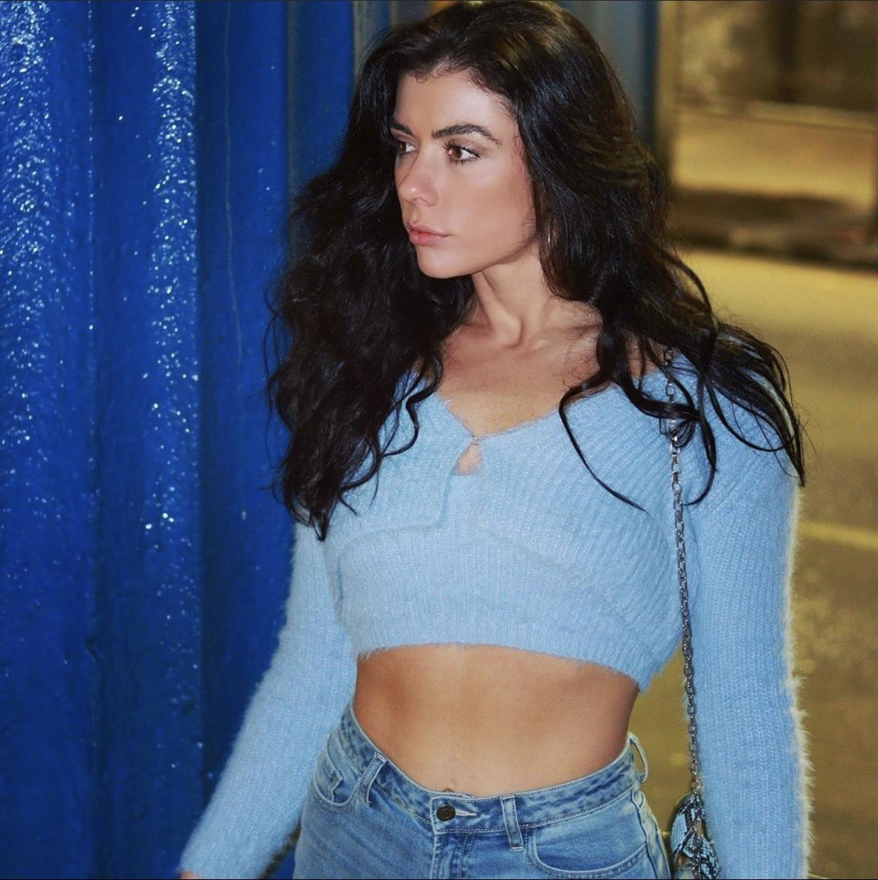
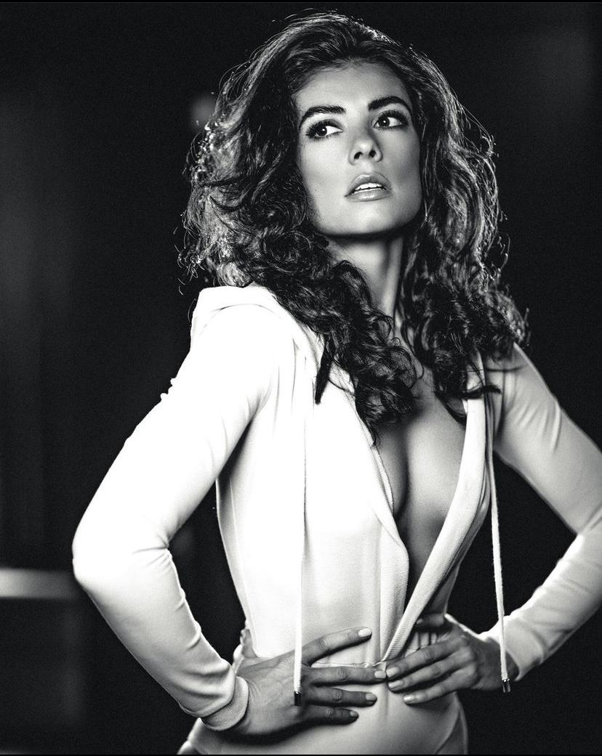
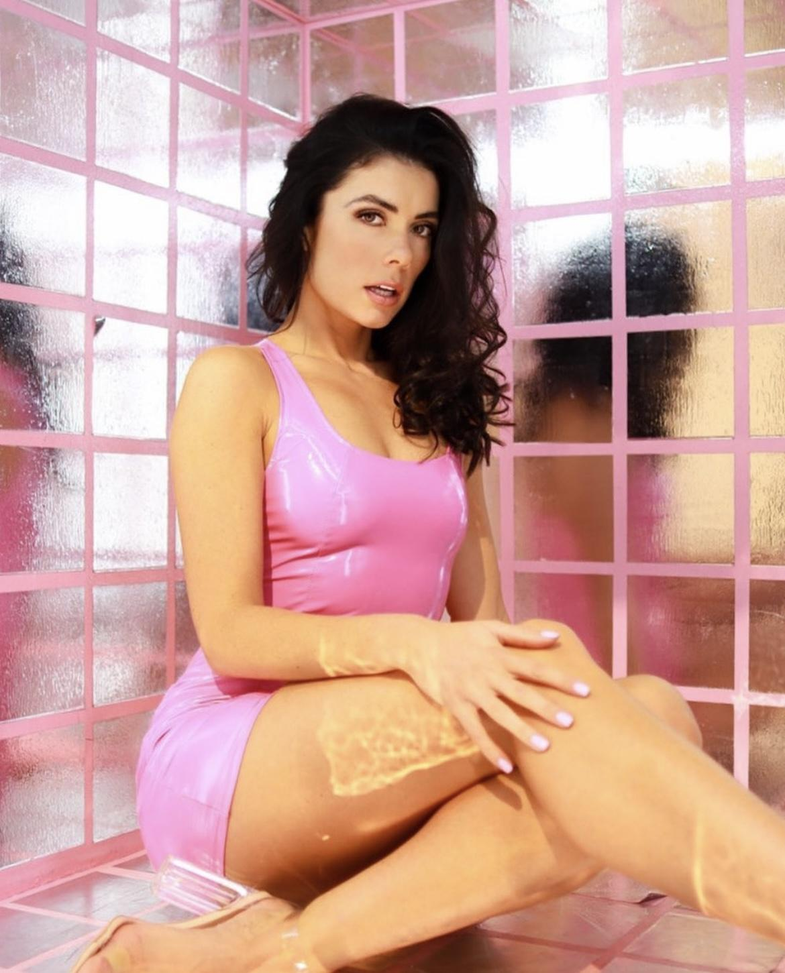
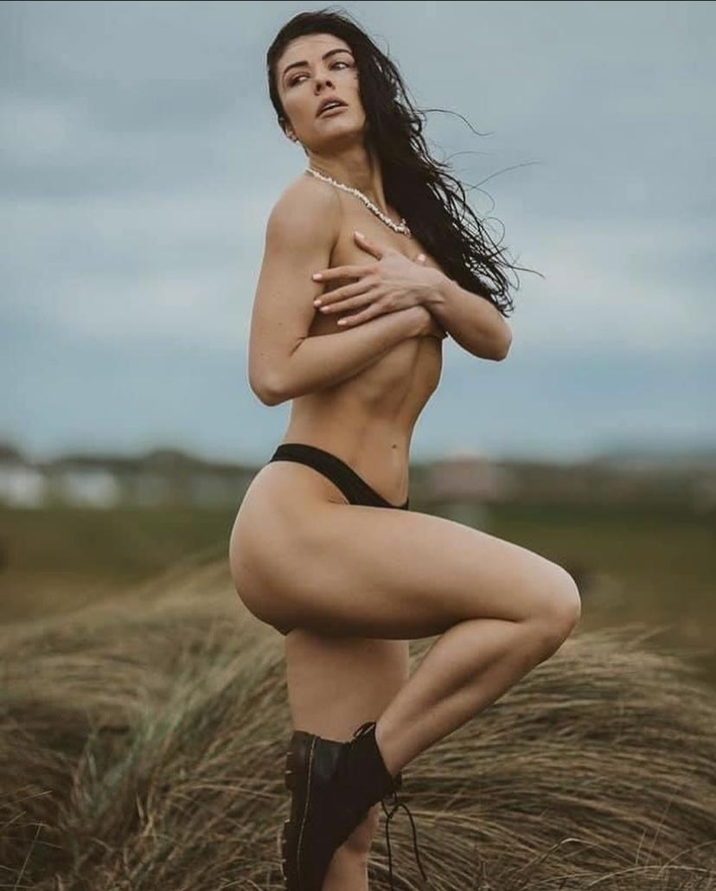
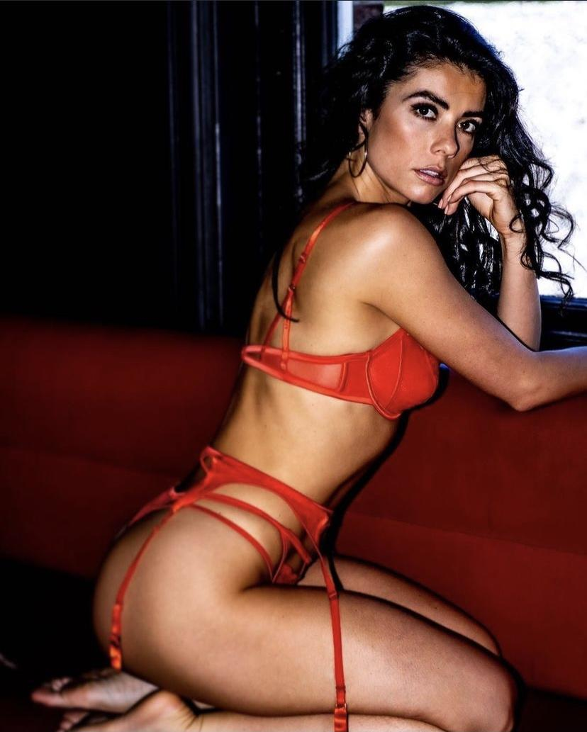
ROSEY-VICTORIA .
Hey, my name is Rosey and I specialize as a commercial model, certified fitness trainer, dancer UGC Content creator and event promotional modeling.
In my spare time I like to nourish my body by cooking healthy meals and working out to stay in shape and to bring amazing energy on set. I love meeting new people, traveling and trying new experiences. I love making people feel happy and at ease and would describe myself as a people person.
During my years of experience I have had the opportunity to model in the UK, Spain, Abu Dhabi, France and Croatia alongside working as a brand ambassador and a model for some amazing brands such as GHD, Loreal, Zen Hair, Monster Energy, Thorntons chocolate, AU Vodka, Amazon, Netflix, Anne Summers, New look, Matchroom boxing, Silk & Fred, Forever Unique Formula One.
I have experience in swimwear campaigns,content creation, ring girl, ecommerce modeling, hair and beauty brands, campaigns, small acting roles, events, hospitality management, marketing emails, content creation and hostessing.
MODELLING EXPERIENCE.
- E COMMERCE MODELING
- SWIMWEAR & LINGERIE
- ADVERTS
- CAMPAIGNS
- FITNESS
- HAIR CAMPAIGN
- SKINCARE CAMPAIGN
ACTING EXPERIENCE
- SHORT FILMS
- COMMERCIALS
- TUTORIAL VIDEOS
- FEATURE FILM
DANCING EXPERIENCE
- IN HOUSE DANCER / ANNABELLES
- IN HOUSE DANCER SEXY FISH
- EVENTS
- PROMOTIONAL MODELLING
- RING GIRL
- GRID GIRL
- HOSTESS
- EXPO’S

